Please turn on your computer.
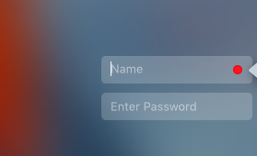 | Student will enter “guest” in the Name box and “guest” in the box Enter Password.  Lenova computers: lunch #, password  MacAir: guest, guest
 | Student will click to sign in to myPasco Connect (blue box in center of screen).
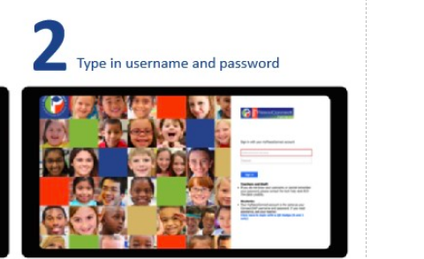 | Student will enter their user name (student ID#/lunch number) and password (e.g., crickets21!). (If your student does not remember their password, please use the parent portal to locate it.)
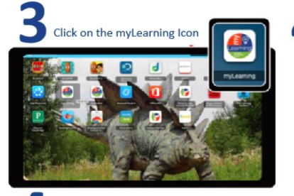 | Student will click on myLearning icon to access the courses.
   | Look to the left of the screen. There is a blue bar. Student will click on the inbox. The student should see a Zoom invitation for our first meeting. Click on the Zoom invitation.

