Send a Message: Stay Drug Free!
Wednesday October 23 | “RED Day” Wear red
Thursday October 24 | “Put a CAP on drugs” Wear a hat
Friday October 25 | “Turn your BACK on drugs”  Wear your clothes backwards
Monday October 28 | “Too BRIGHT for drugs”  Wear sunglasses and/or neon attire
Tuesday October 29 | “SOCK it to drugs”  Wear crazy socks
Wednesday October 30  Thursday October 31 | “Be on a Drug Free Team” Wear Your Favorite Team Gear  “Say BOO to drugs!”  Halloween Parade
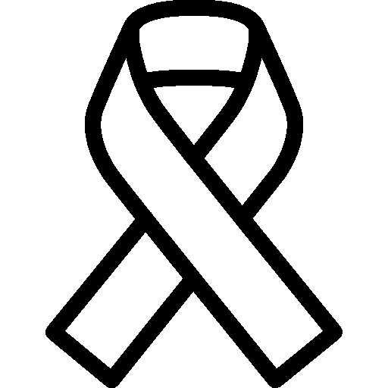
Gulf Highlands Elementary School

RED RIBBON WEEK
October 23 - 31

