- Click on the “Self Service” icon from your device.

- If on a laptop, search “zoom” in the upper left corner, then click install under the blue zoom icon. Then follow the directions on the screen to install.
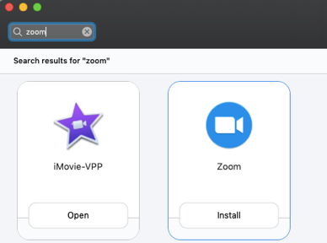

If on an iPad, scroll down in Self Service until you see the blue “ZOOM Cloud Meetings” App and click on it to install.
